**PSST Technical Workshop  
MAY 21, 2016 LAHORE**

1. UTILIZING MODERN / UPDATED ENERGY SAVING TECHNIQUES TO EXPLOIT BY PRODUCTS FOR BETTER ECONOMY OF SUGAR INDUSTRY.

Mohammad Sarfaraz Khan

GM (Plant)

Ramzan Sugar Mills, Chiniot

**INTRODUCTION**:-

* The term Sugar cane byproduct comprises primarily on bagasse, Molasses & Press mud. However, their contribution would be more or less 30, 5 & 3 % on cane respectively. While, cumulative reflection remains 37– 38%.
* Principally, byproducts contribute to curtail cost of production to measurable & even survival extent. Amongst all, bagasse due to their 30% larger share has greater opportunity to utilize as prime byproduct to reduce cost with energy efficiency.
* By & large, bagasse itself utilize to generate power production on cheapest cost as compared to other sources of fuel. Currently, country – wide sugar industry, utilized bagasse to generate power @ 10 - 12 KG/KWH for self-generation. However, Cogeneration can reduce its consumption to 5 KG/KWH which is tremendous opportunity for sugar industry to make it proficient.
* With latest techniques steam consumption can be reduced from conventional 50 to 36 – 42% on cane. In order to focus potential opportunities to save bagasse or energy, five distinct areas i.e. a) Mill house Electrification, b)Installation of FFE with integrated vapor distribution, c)capacity utilization, d)Milling equipment & finally e)Plant automation significantly contributes towards optimization with justified pay back.





**SPECIFIC STEAM % FOR PROCESS sections**

Process applications are classified with ± 3 – 4% variation at individual plants. While reference base scenario to save energy to produce bagasse as follows;

Juice heating = 8.2 %

Evaporators = 20 %

Vacuum Pans = 12 %

Miscellaneous = 5 %

(Pan washing, Centrifugals)

**Total = 45.2 % on cane**

**FALLING FILM EVAPORATORS**

* FFE is an established feature to bring down steam% with certain design & operational advantages,
* Short residence time
* High heat transfer coefficient
* Minimum effective temperature difference
* Flexibility at capacity fluctuations
* Local design & manufacturing facility
* 10 - 20 % factories have inducted

**Automation**

* Automation provides the best optimum control of any equipment or process. Comparing to manual control, where performance fluctuates in between two extremes, i.e. optimum best control and worst control due to the various reasons.
* Automation facilitates 3 - 5% capacity enhancement at milling applications to overcome momentary stoppages
* Consistency at process applications stabilize quality and phase changes.
* Data control monitoring leads to 4 - 6 % improvement.
* Automation controls the equipment or process to highest possible level. A graphical reflection regarding manual and auto control of defecation juice p.H

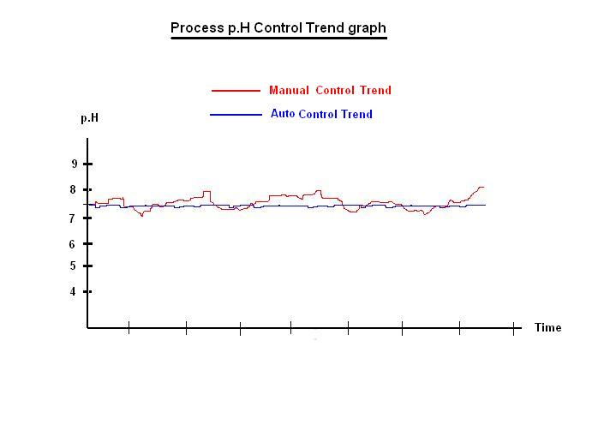

**APPLICATION OF 2 ROLLER MILL**

|  |  |  |  |  |  |
| --- | --- | --- | --- | --- | --- |
| **Comparison of Conventional Mill Units of various configuration operating in Pakistan** | | | | | |
| Installed/Absorbed Power calculations based on 8000 TCD crush rate @ 14% fibre | | | | | |
| **Mill Type** | **Conventional** | **Conventional** | **Conventional** | **Conventional** | **(2 Roller Mill)** |
| Pressure Rollers | 3 | 3 | 3 | 3 | 2 |
| Additional Roller | 1 | 2 | 3 | 3 | 1 |
| (Pressure Feeder / Under Feed) |
| Unit Configuration | Three Roller with | Three Roller with | Three Roller with grooved | Three Roller with grooved | 2RM |
| under feed | Toothed Pressure Feeders | M.D.P.F plus U. F | HD P.F plus U. F |
| Installed Power(KW/TFH) | 18* | 20* | 22* | 23* | 14** |
| *Turbine driven) |
| **(Motor-VFD driven) |
| Absorbed Power (KW/TFH) | 13.5 | 15 | 16.5 | 17.25 | 10.93 |
| Absorbed Power % | 19.03 | 27.13 | 33.75 | 36.63 | Comparison (Reference (10.93) |
| With respect to **(2RM)** |
| Maintenance Cost | Moderate | High | High | High | Low |
| First Mill Extraction (**%)** Plain**/Reduce Mittal** | 71.06/ **74.87** | 72.38/**75.71** | 70.31/**71.87** | 71.00/**73.46** | 74.14/**77.38** |
|  |

**POWER COMPARISON**

**BASE LINES FOR EFFICIENT STEAM UTILIZATION IN SUGAR PLANTS (ESTIMATIONS)**

1. Energy Inputs from Bagasse 91.7%
2. Energy Inputs from way of condensate return 8.3%
3. Energy recovered in steam of total Energy 64.6%
4. Contributed by de-superheating water 0.4 %

**Total heat available in steam from boilers distributed as;**

1. For Process heating, boiling 71.8 %
2. For Prime Movers 6.9 %
3. Recovered in hot exhaust condensate 13.3 %
4. Radiation , leakages and Others 8 %

**Conclusion**

* Entire aspects as discussed ultimately reflects the significance of bagasse saving. A crucial byproduct will going to be a costly commodity in coming years due to switching of multiple conventional sugar mills to Cogen mode. However, availability since November 2015 ranges between Rs. 3000 – 5000/ton shows the rising trend. Therefore, Bagasse as energy fuel can contributes for the future - survival of sugar industry.

**ACKNOWLEDGEMENT**

* Author is extremely thankful for the Management of Ramzan Sugar Mills for their support and kind approval for this presentation at PSST workshop.